Chapter 12, Solution 39.

Find the real power absorbed by the load in Fig. 12.58.

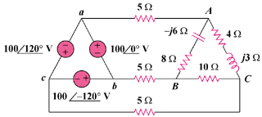

Figure 12.58
For Prob. 12.39.

Solution

Consider the system shown below.

+

1000

100120

100-120

+

+

a

b

c

4

8

A

C

B

j3

10

-j6

5

5

5

I₃

I₁

I₂

For mesh 1,
(1)

For mesh 2,
(2)

For mesh 3,
(3)

To eliminate , start by multiplying (1) by 2,
(4)

Subtracting (3) from (4),
(5)

Multiplying (2) by ,
(6)

Adding (1) and (6),
(7)

In matrix form, (5) and (7) become

, ,

We obtain from (6),

The average power absorbed by the 8- resistor is

The average power absorbed by the 4- resistor is

The average power absorbed by the 10- resistor is

Thus, the total real power absorbed by the load is

